**Below is project folder structure. It follows 3 tier architecture.**

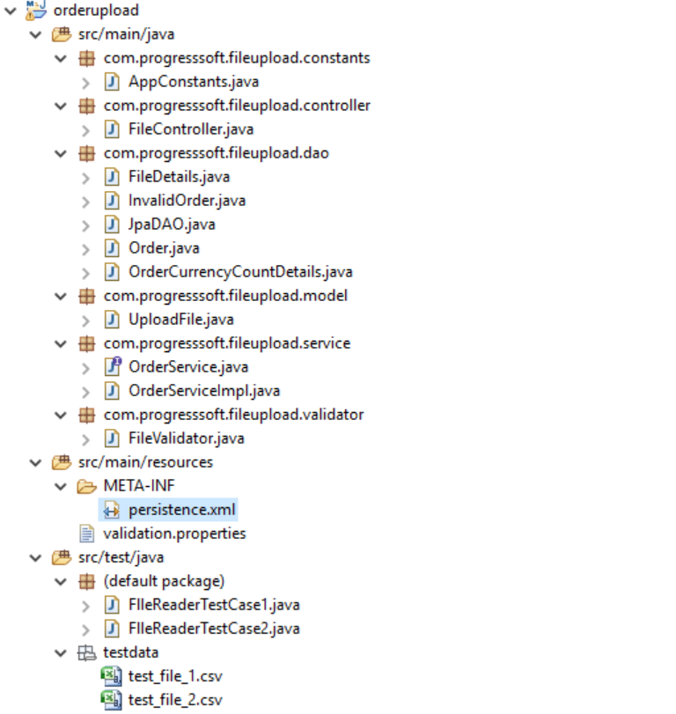

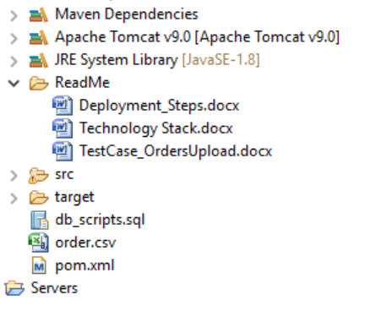

Below are list of technologies/tools used to develop the project

* Jdk1.8
* Jre8
* Spring Core
* Spring MVC
* JPA
* MySql 5.6
* Apache Maven 3.0.4
* Apache Tomcat 9.0.1
* Eclipse IDE - Oxygen
* Apache commons